From: https://davidstockmanscontracorner.com/it-doesnt-get-any-dumber-than-this/

It Doesn't Get Any Dumber Than This
By David Stockman. Posted On Monday, March 11th, 2019
It was another Looney Tunes day on both ends of the Acela Corridor. Even though the robo-machines made another panicked run to their putative "safe space" slightly above the 200-DMA (2750) on the S&P 500, we doubt whether landing there for the 5th time since PEAK TRUMP on last September 20 will prove to be the charm.
In fact, the decoupling between the stock market averages and reality has now become downright palpable. Wall Street is literally crawling with financial corpses who just don't know it yet---probably because they are too fat, happy and complacent to even recognize that the prevailing "it's OK" narrative has now become about as dumb as it gets.
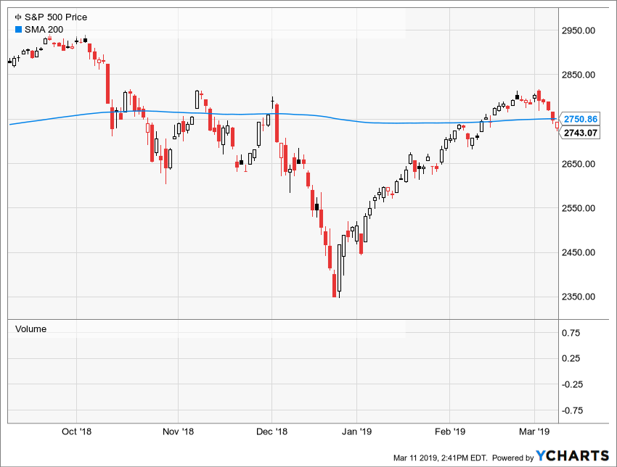
After all, there are economic, financial and political headwinds, storm clouds and booby traps lurking everywhere.
For example, the US economy is rapidly lapsing into stall speed, as indicated by two more releases this morning. The big plunge in December retail sales was apparently not the "fluke" it was cracked up to be---since January's seasonally adjusted figure were still down 1.4%from November, and has now flat-lined all the way back to the May 2018 level.
That's right. These are in nominal dollars---meaning that if you factor in the 2.2% Y/Y rise in the CPI during that 8-month period, real retail sales are shrinking; and that's notwithstanding the $190 billion annual rate of family tax relief that the Trumpite/GOP put into taxpayer pockets on Uncle Sam's credit card.
You truly do not need a PhD to recognize what is happening on the economic home front as per the chart below. Except...except if you're a high paid Wall Street fund manager like the bimbo we saw on bubblevision expressing optimism that consumer spending came bouncing right back in January!
Actually, December's originally reported, disastrous 1.2% retail sales decline was revised down to an even deeper 1.6% drop. Accordingly, today's ballyhooed 0.2% January gain would have actually been a 0.2% decline based on what was assumed to be the case a nanosecond before the release.
That is to say, what passes for Wall Street analysis these days is about as pathetic as the proverbial keen-eyed farm boy who claimed an ability to spot discarded bubble gum on the chicken coop floor.
Likewise, the December figure for construction spending released this AM was even more punk. It was down 0.6% from prior month, but, more importantly, now stands 2.4% below its May 2018 level.
The fact, is there has been no Trump Boom whatsoever---just a short-lived sugar high reflected in inventory building and export pull forwards owing to the Donald's Trade War, as we demonstrated on Friday.
When you remove these transient factors, the two-year gain in real final sales less exports has been 2.5% under Trump compared to 2.4% under Barry's last two years in the Oval Office; and both figures are, in fact, nothing to write home about--just mediocre late cycle rates which have nowhere to go except down.
As shown in the chart below, that's exactly what is happening on main street. Yet Wall Street today was buying the dip and the White House was releasing a 15-year budget outlook and Rosy Scenario economic forecast that gives the concept of fiscal fiction an altogether new meaning.
That is to say, on a honestly reckoned basis and even with the inherited momentum of a late-cycle economy, the growth rate during the Donald's eight quarters in the Oval Office has not come close to 3.0%. Yet his FY 2020 budget released this morning assumes a 3% + economy for the next 15 years.
Stated differently, the palace clowns who pass for the Donald's economic advisors projected a balanced budget by 2034 on the assumption that the US will go for 300 months (2009-2034) without a recession!
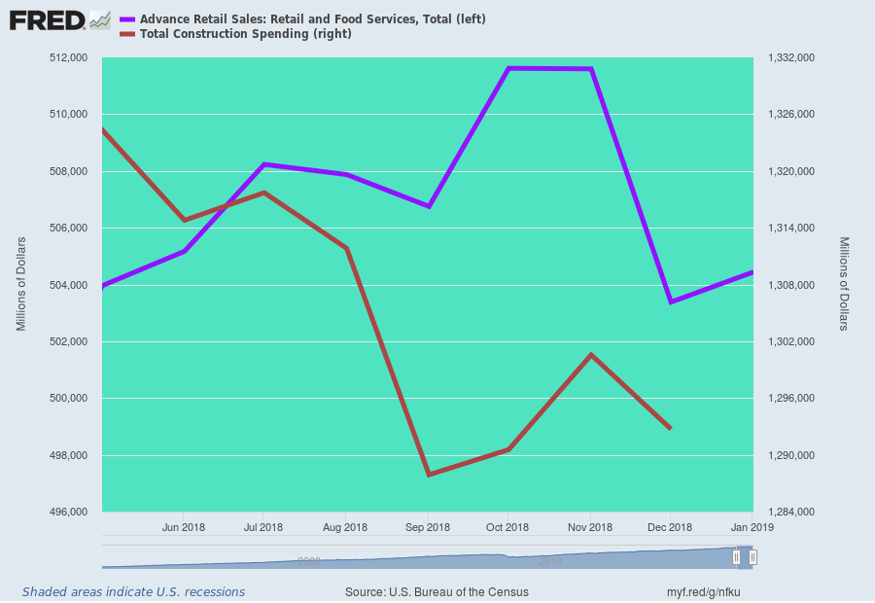
Then again, the real import of today's releases is that the purported permanently banished spot of economic unpleasantness known as a recession might well be underway right now---not another 185 months unto the opaque future.
Indeed, what today's reality downloads actually remind us about is that the prevailing mainstream narrative speaks only in the future tense, owing to the intellectual tyranny of the cult of central banking.
That is, if the economy is sailing smoothly the Fed won't dare upset the Wall Street applecart by permitting honest price discovery in the casino; and if storm clouds are gathering (like at present) the Fed and other central banks will do "whatever it takes" to overcome or offset the bad news.
That's the only way you can explain today's nonchalant response to the Atlanta's Fed latest markdown of its Q1 GDP estimate to just 0.2%---especially because this came 70 days into the quarter when a large share of the data driving the Q1 print have already been posted and factored into the Atlanta Fed's projection.
As Zero Hedge observed, we might well be merely 0.2% away from economic contraction. But no matter.
It apparently means that we are also only a Fed meeting or two away from the next round of rate cuts, QE and whatever else our monetary central planners can concoct to defile the laws of sound money and disciplined, sustainable finance.
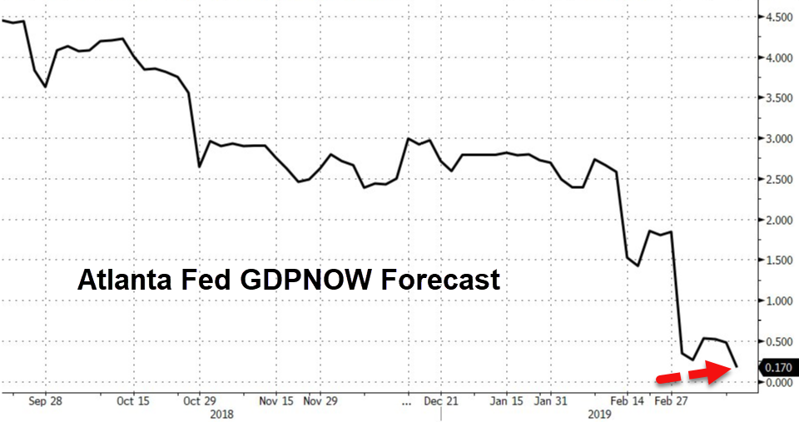
Nor are the headwinds mainly domestic. Today Bloomberg also released its global GDP outlook for Q1 and it, too, was heading for the drink.
The global economy’s sharp loss of speed through 2018 has left the pace of expansion the weakest since the global financial crisis a decade ago, according to Bloomberg Economics.
Its new GDP tracker puts world growth at 2.1 percent on a quarter-on-quarter annualized basis, down from about 4 percent in the middle of last year. While there’s a chance that the economy may find a foothold and arrest the slowdown, “the risk is that downward momentum will be self-sustaining,” say economists Dan Hanson and Tom Orlik.
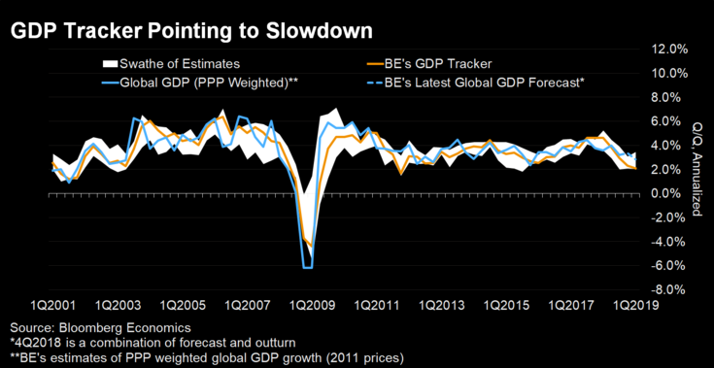
The fact is, the ECB is in full recession panic mode, as trumpeted by last week's pivot into massive money printing, again; and exports from the world's factory zone in East Asia are collapsing as measured by plunging year-to-date figures for South Korea, Japan, China and elsewhere.
In fact, the most recent readings show exports from these bell weather economies down by between 6% and 19%; and even then, the full impact of the Donald's Trade Wars has not yet impacted the numbers.
South Korean Exports Down 5.8% In January
Japanese Exports Down 8.4% In February
China Exports Down 21% in February
But never mind the ill winds from abroad, the punk action on main street or the fact that at month #116 of the most ragged recovery in history, the US economy has "recession" written all over its forehead.
That's because word came today from Imperial Washington that even a simulacrum of fiscal responsibility is now deader than a doornail. To wit, the Trump budget proposes to add $4.2 trillion to the public debt over FY2020-2023 alone, but that's likely to be only the tip of the Debtberg.
That's because the shameless shills who provide the Donald with economic and fiscal advice have the gall to assume that the US economy will grow at a 3%+ rate during what would be month #123 thru #171 of the current tattered recovery; and that domestic spending will be slashed by $611 billion during that period from motherhood programs that 80% of the House and Senate GOP wouldn't touch with a ten-foot pole.
When it comes to the growth and business cycle assumption, of course, we have never been there before in all of American history. The tech boom of the 1990s lasted only 119 months and the second longest cycle, the "guns and butter" expansion of the 1960s, rolled-over into recession after 105 months. Even then, both of these cycles were the outliers for longevity given that the average recovery has lasted only 63 months.
So what we are saying is that when you read through the budgetary flim-flam, the Donald has actually proposed a deficit which will hit $2 trillion per annum as soon as the impending recession arrives, and it will be katy-bar-the-door from there.
In Tuesday's post, we intend to address how in the world it came to pass that the once and former party of fiscal rectitude ended-up fronting for the fiscal calamity that the Donald has now made official policy by today's shameful excuse for a budget.
We referred to this as the Trumpite/GOP war on the nation's very fiscal solvency during a debate with White House shill, Steve Moore, on CNN last Friday night. Yet perhaps Moore inadvertently hit the nail on the head when he whined about the Fed pushing interest rates up to what amounts to a mere 0.2% real rate after inflation.
Stated differently, even the so-called conservative economic party has been euthanized by the Fed's massive and sustained era of financial repression and the monumental level of official financial fraud embedded in upwards of $22 trillion of central bank debt monetization since the turn of the century.
https://www.youtube.com/watch?v=Pc6p_4Syab4&feature=youtu.be

We will have much more to say about Powell's vaporous interview on 60 Minutes in tomorrow's installment, but Jim Kunstler more than set the table in today's well justified screed:
Maybe it was an hallucination, but I heard him say that “the economy is in a good place,” and that “the outlook is a favorable one.” Point taken. Pull the truck up to the loading dock and fill it with Tesla shares! I also thought I heard “Inflation is muted.” That must have been the laugh line, since there is almost no single item in the supermarket that goes for under five bucks these days. But really, when was the last time you saw a cigar store Indian at Trader Joes? It took seventeen Federal Reserve math PhD’s to come up with that line, inflation is muted.
What you really had to love was Mr. Powell’s explanation for the record number of car owners in default on their monthly payments: “…not everybody is sharing in this widespread prosperity we have.” Errrgghh Errrgghh Errrgghh. Sound of klaxon wailing.
What he meant to say was, hedge-funders, private equity hustlers, and C-suite personnel are making out just fine as the asset-stripping of flyover America proceeds, and you miserable, morbidly obese, tattooed gorks watching this out on the Midwestern buzzard flats should have thought twice before dropping out of community college to drive a forklift in the Sysco frozen food warehouse (where, by the way, you are probably stealing half the oven-ready chicken nuggets in inventory).

